
Lewisham Citizens Borough Training

Join us for a time of training, planning, celebrating on:
Saturday, 4 February, 2012, 1pm-5pm
At St Andrew’s United Reformed Church, Brockley, SE4 2SA
(Buses: 122, 172, 176, P4)

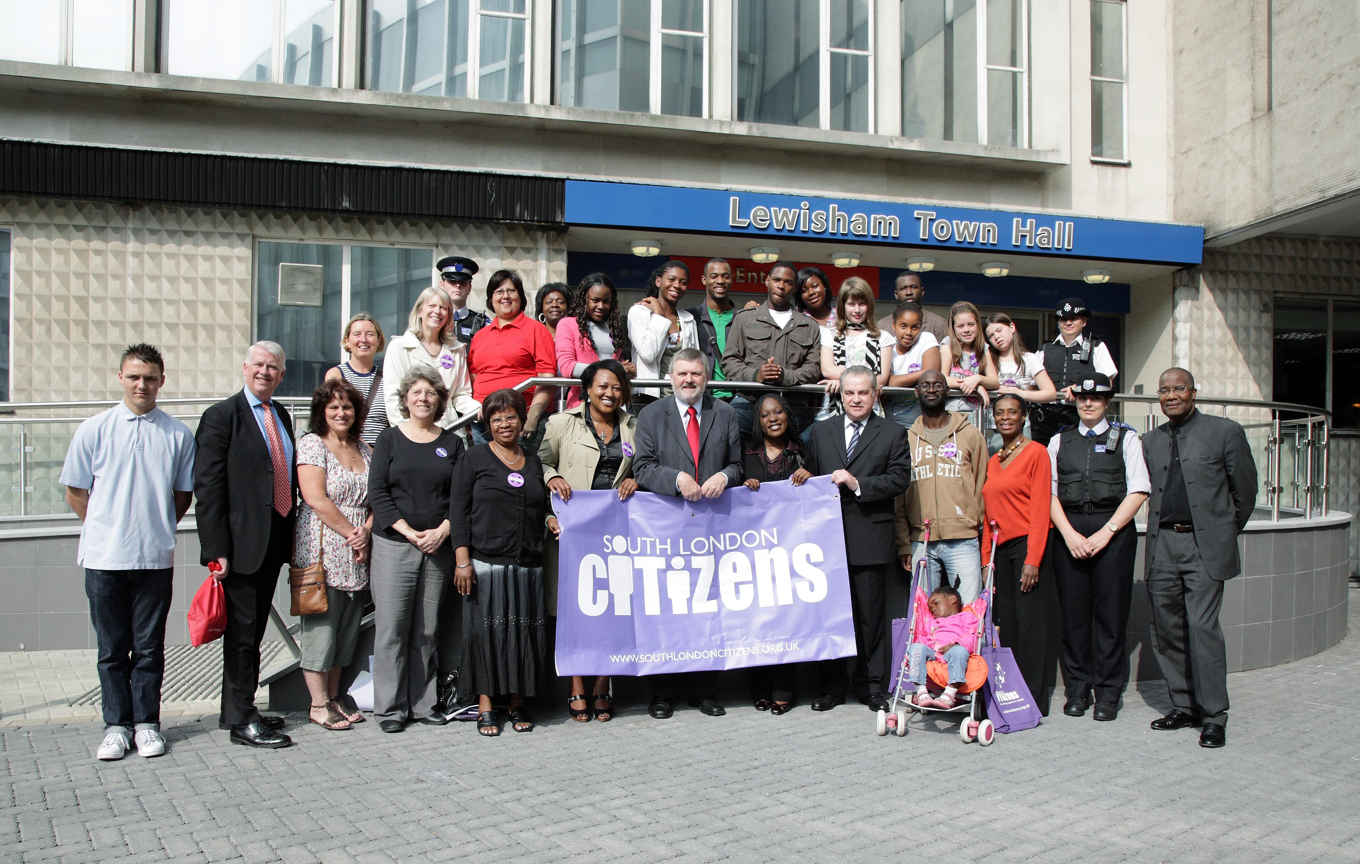

‘Building Power for Local Change

